./

Learning Report – Applied System Development Life Cycle and Software Testing



|  |  |  |  |  |  |
| --- | --- | --- | --- | --- | --- |
| **Ver. Rel. No.** | **Release Date** | **Prepared. By** | **Reviewed By** | **To be approved By** | **Remarks/Revision Details** |
| Sl.no |  | Name/PS No | Name/PS No | Module Owner Name | Comments |
| 2 | 15/2/21 | Shiva Kumar /99003727 |  |  |  |
|  |  |  |  |  |  |
|  |  |  |  |  |  |
|  |  |  |  |  |  |

**Document History**

Table of Contents

Table of Figures 3

Table of Tables 4

ACTIVITY 1: SYSTEM/ SOFTWARE DEVELOPMENT 4

**INTRODUCTION** 4

MY PRODUCT:"CALCULATOR"…………………………………………………………………………………………………………………………………......4

**SWOT ANALYSIS**…………………………………………………………………………………………………………………………………………………………..5

C**OST AND FEATURE**S………………………………………………………………………………………………………………………………………………………………………..5

**REQUIREMENTS** 7

**UML DIAGRAMS**…………………………………………………………………………………………………………………………………………………………..7

HIGH LEVEL DESIGN 8

LOW LEVEL DESIGN1………………………………………………………………………………………………………………………………………………..8

**TESTPLANS**…………………………………………………………………………………………………………………………………………………………………..9

**REFERENCES**…………………………………………………………………………………………………………………………………………………………………9

ACTIVITY 2: AGILE METHODOLOGY………………………………………………………………………………………………………………10

**THEME**………………………………………………………………………………………………………………………………………………………………………10

**EPIC**…………………………………………………………………………………………………………………………………………………………………………..10

**USER STORY**………………………………………………………………………………………………………………………………………………………………13

**references**........................................................................................................................................................................13

## Table of Figures

Figure 0 SWOT ANALYSIS……………………………………………………………………………………………………………………………….06

Figure 1 USE CASE DIAGRAM (HIGH LEVEL01)……………………………………………………………………………………………….08

Figure 2 State Diagram for low level requirement2……………………………………………………………………………………….09

Figure 3 DEPLOYMENT BEHAVIORAL DIAGRAM (LOW LEVEL2)………………………………………………………………………10

Figure 4 CODE IN GIT……………………………………………………………………………………………………………………………………..12

Figure 5 CALCULATOR EXE FILE………………………………………………………………………………………………………………………12

Figure 6 GIT COMMITS…………………………………………………………………………………………………………………………………..13

## Table of Tables

Table 1: High level requirement………………………………………………………………………………………………………………..5

Table 2:Low level requirement…………………………………………………………………..................................................5

Table 3:Test plan for low level and high level requirement……………………………………………………………………….11

**ACTIVITY 1: SYSTEM/ SOFTWARE DEVELOPMENT**

**INTRODUCTION:**

A calculator is a machine which allows people to do math operations more easily. For example, most calculators will add, subtract, multiply, and divide. Some also do square roots, and more complex calculators can help with calculus and draw function graphs. Calculators are found everywhere.

**MY PRODUCT: “CALCULATOR”:**

**Features:**

* Basic functions and exponents. Calculate basic functions such as addition, subtraction, multiplication, and division
* Basic conversions such as from degree to radians and from radians to degrees.
* Mathematical functions such as square root, cube root, square, cube, factorial.
* Making Built in functions which are necessary for signal processing and mathematics as well like mensuration calculations.

**High Level Requirements:**

|  |  |
| --- | --- |
| H_L 1 | Arithmetic operations |
| H_L 2 | Conversions |
| H_L 3 | Mensuration calculations |
| H_L 4 | Basic operations |

**Table1 : High level requirement**

**Low level requirements:**

|  |  |
| --- | --- |
| L_L 1 | Addition, Subtraction, Multiplication, Division, Modulus. |
| L_L 2 | Area of Rectangle, Circle, Triangle and Polar to Rectangular, Rectangular to polar. |
| L_L 3 | Square root, Cube root, Square, Cube, Factorial of the given number. |
| L_L 4 | Conversion from radians to degree and vice-versa. |

**Table2: Low level requirement**

**COST AND FEATURES:**

cost

|  |  |  |
| --- | --- | --- |
| Basic calculator | Non-Programmable calculator | Printing calculator |
| Mini Calculator | Scientific calculator | Graphical calculator |
| Abacus | Financial calculator | Programmable calculator |

Features

**SWOT ANALYSIS:**

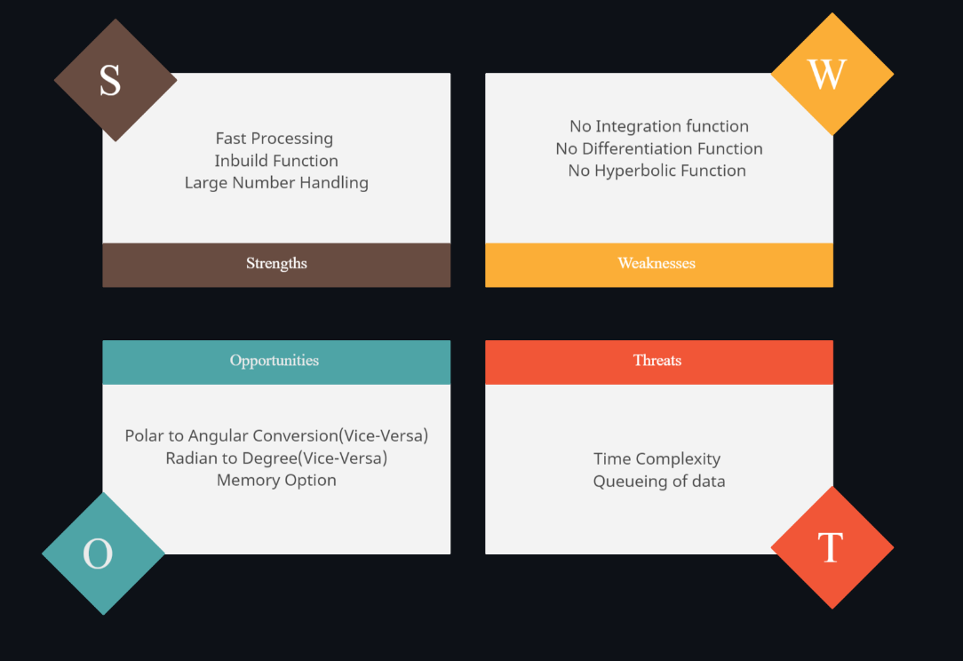

**Fig 0:Swot analysis**

**Requirements:**

**4W1H:**

**WHO:**

Students and research people.

**WHAT:**

Advance Programming calculator.

**WHEN:**

For signal processing and basic calculations.

**WHERE:**

Research work and iterative work.

**HOW:**

By using the math functions and built in libraries.

**UML Diagrams:**

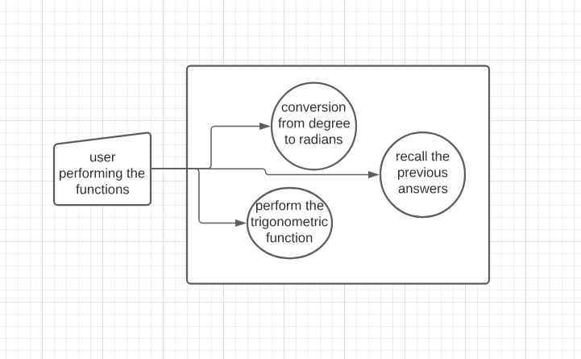

**FIG1: Class Diagram in structural for High level requirements**

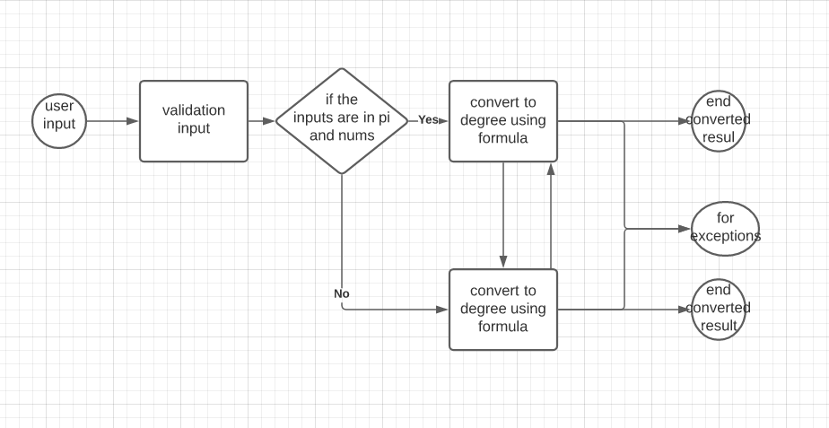

**FIG2: State Diagram for low level requirement for conversion**

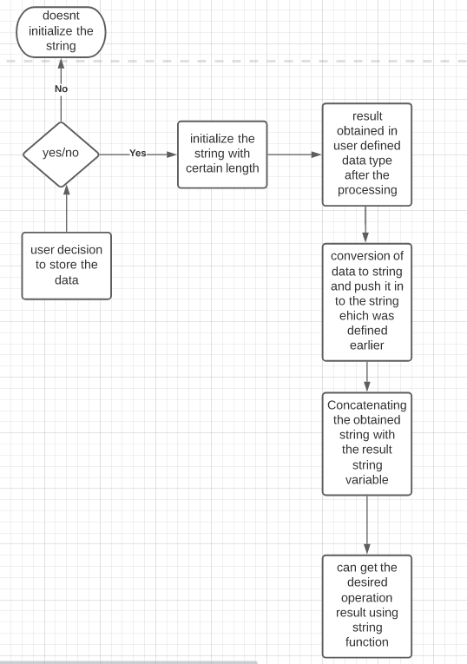

**FIG3: Deployment behavioral diagram for low level requirement**

**Test Plans:**

|  |  |  |  |  |  |
| --- | --- | --- | --- | --- | --- |
| Requirements | Description | Given Input | Expected output | Actual output | Type of Test |
| H_L 1 | Input taken as string for conversion | adfjh | Invalid input | Invalid input | Scenario based |
| L_L 1 | Input given is degree to into convert radian | 90 | 1.5708 | 1.5708 | Scenario based |
| L_L 2 | Input given is radian to convert in to degree | 1.5708 | 90 | 90 | Scenario based |

**TABLE 3:TEST PLAN FOR THE HIGH LEVEL AND LOW-LEVEL REQUIREMENT**

**References:**

1. <https://www.tutorialspoint.com/sdlc/sdlc_overview.htm#:~:text=Software%20Development%20Life%20Cycle%20(SDLC,and%20test%20high%20quality%20softwares.&text=It%20is%20also%20called%20as,in%20the%20software%20development%20process>.
2. https://phoenixnap.com/blog/software-development-life-cycle.

**ACTIVITY 2: AGILE METHODOLOGY**

**THEME: CALCULATOR**

**EPIC STATEMENT:**

| **Funnel Entry** | **15/02/2021** |
| --- | --- |
| **Epic Name** | Calculator by team 1 |
| **Epic Owner** | Team 1 Takshashila |
| **Epic Description** | To convert the given data from degree to radian and from radian to degree  To store the data of previous operations. |
| **Business Outcomes** | A new hype for product in research communities, Colleges and various institutions, High demands for calculators from these communities |
| **Leading Indicators** | A calculator being stolen is a common in colleges and universities and finding it back is next to impossible. A lot of time is taken and a lot of mistakes are done in parenthesis initialization and closing. |

**SNAPSHOTS OF RESULTS**

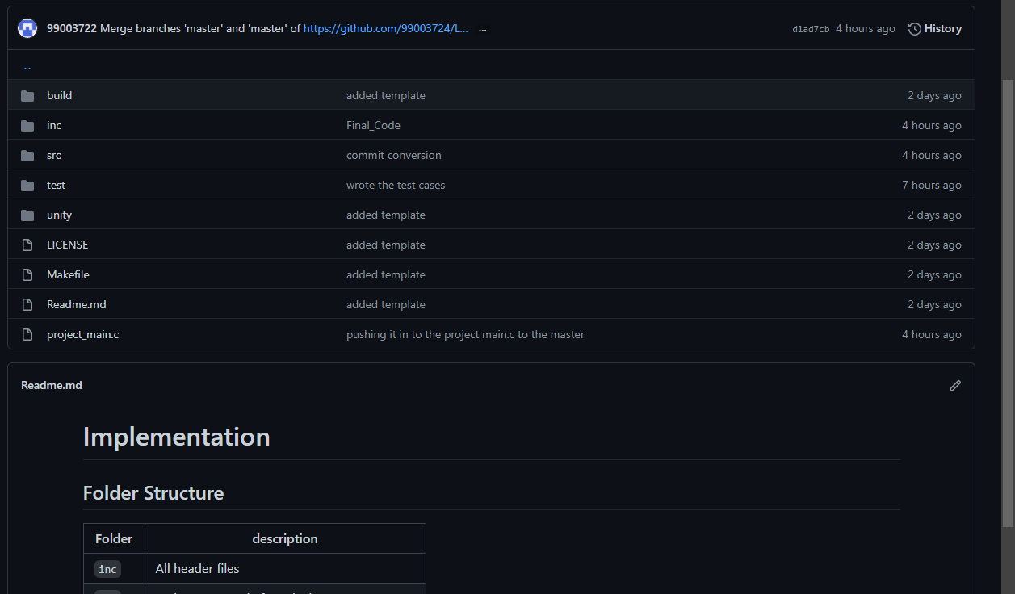

**FIG4: CODE IN GIT**

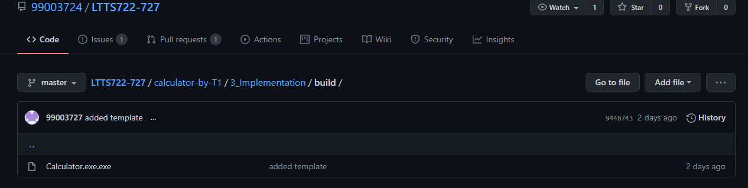

**FIG5: CALCULATOR EXE FILE**

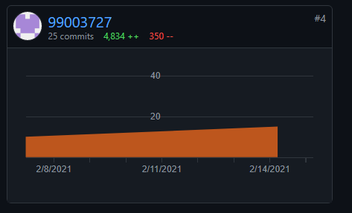

**FIG 6: GIT COMMITS**

**USER STORIES FOR CALCULATOR**

**Story 1**

* As an adult, I wish to manage my finances
* So I need basic arithmetic operations.

**Acceptance criteria**

* For given expenditures and savings of 12000, 15000
* My income would add up to 17000.

**Story 2**

* As a scientist, I would determine the growth and decay rates of various organisms.
* Using power functions.

**Acceptance criteria**

* For a given base 2 and index 5.
* The rate of decay would be 32.

**Story 3**

* As an engineer while to solve the trigonometry functions having radians and degrees.
* I need to convert them accordingly.

**Acceptance criteria**

* For a given degree 90
* My conversion would be 1.357

**Story 4**

* As an architect, I should lay out a design plan.
* I need to use various unit conversions.

**Acceptance criteria**

* For an area of 1428ft, its value in inches is given as 17784.

**REFERENCES:**

* <https://www.cprime.com/resources/what-is-agile-what-is-scrum/>
* https://www.tutorialspoint.com/agile/index.htm